MIC Who Wants to be a Millionaire?
( Maths Challenge )

This year 5th class had great fun participating in the Who Wants to be a Millionaire maths challenge. This involved groups of four engaging in a series of challenges focused on Mathematics .

Challenge 1
The first challenge focused on a series of dice games : The children were given a number of dice and they had to solve several problems using them .
e.g Four dice are thrown on the table. The total of numbers on the top faces of these four dice is 13 as the top faces showed 4, 3, 1 and 5. What is the total of the faces touching the table?
Challenge 2
This challenge focused on 3D shapes. Each group had to examine their shape, record how many faces, edges and vertices it had and find an example of it in the environment.

Challenge 3
In the third challenge the children used one suit of cards to solve problems . The ace stood for 1.
Eg: Using your suit of cards (Ace or 1-10), what is the difference between the largest and smallest 3-digit numbers you can make with your cards? Use the cards to help you!! Work it out in your copy.
Challenge 4
Challenge 4 involved using 7 tangram pieces . The children had to create a four sided shape using 2,3 4 and more than four tangram pieces .
Challenge 5
In this last challenge the children engaged in some fun Sudoku games using pictures and shapes .

5th class really enjoyed these challenges . They worked well in their teams and the Who Wants to be a Millionaire format
Kept them engaged and motivated during the activity . A real fun maths activity .

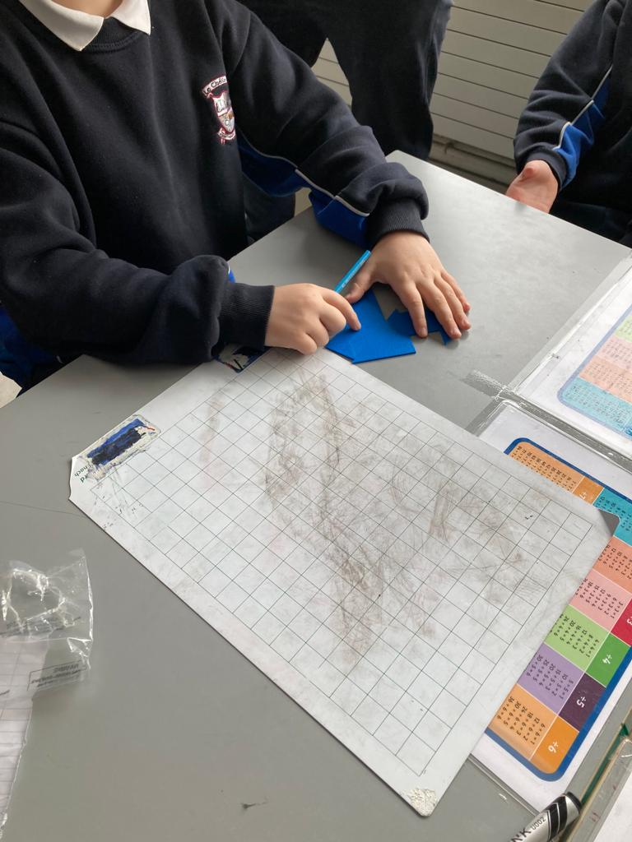

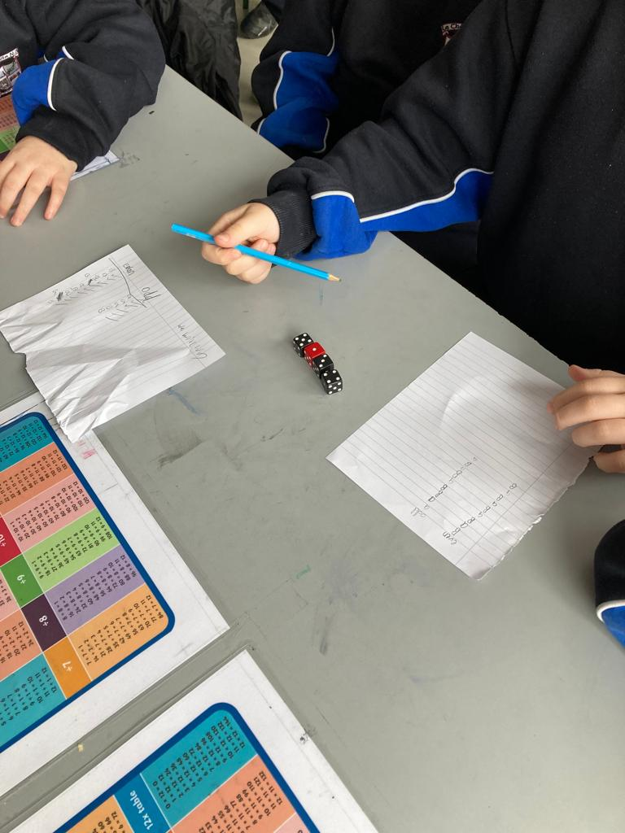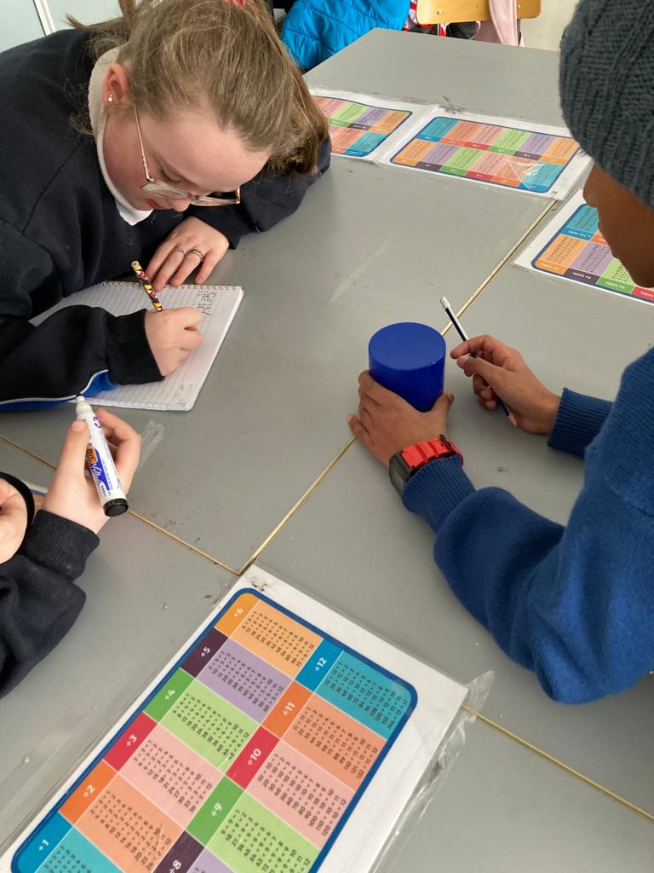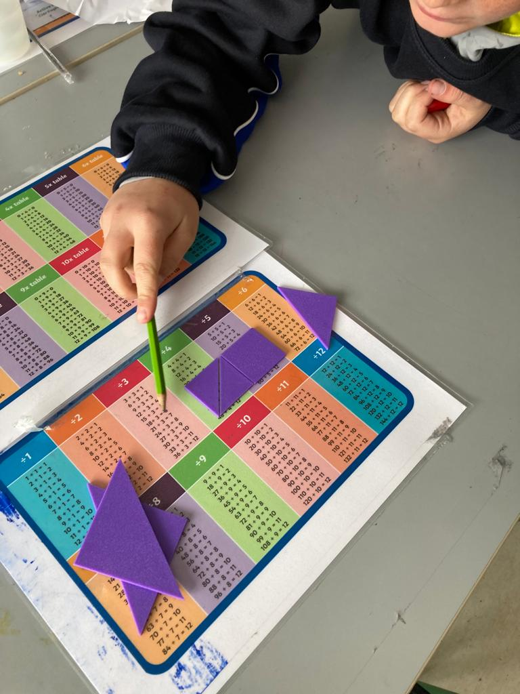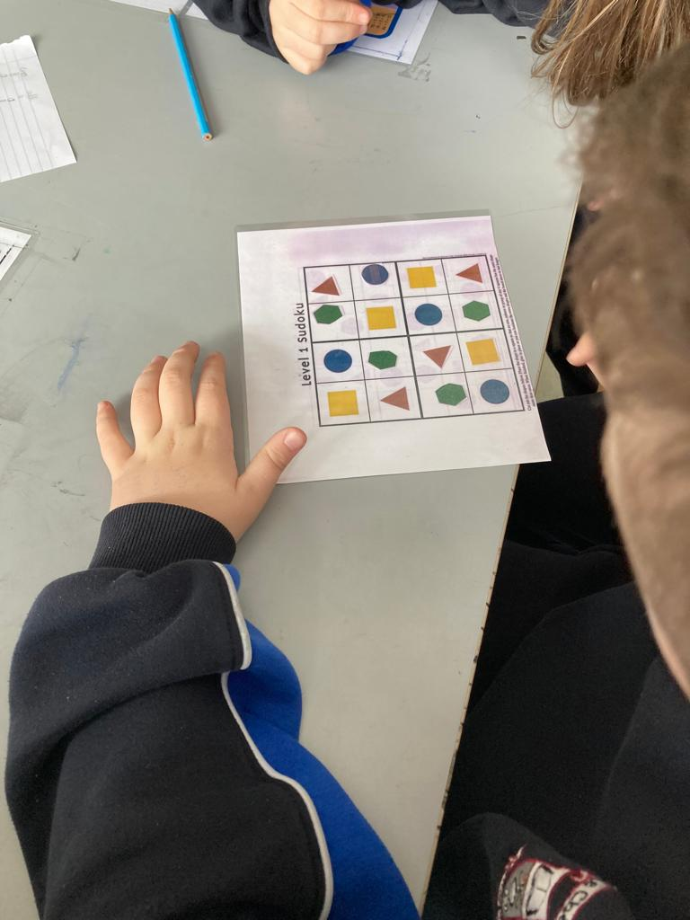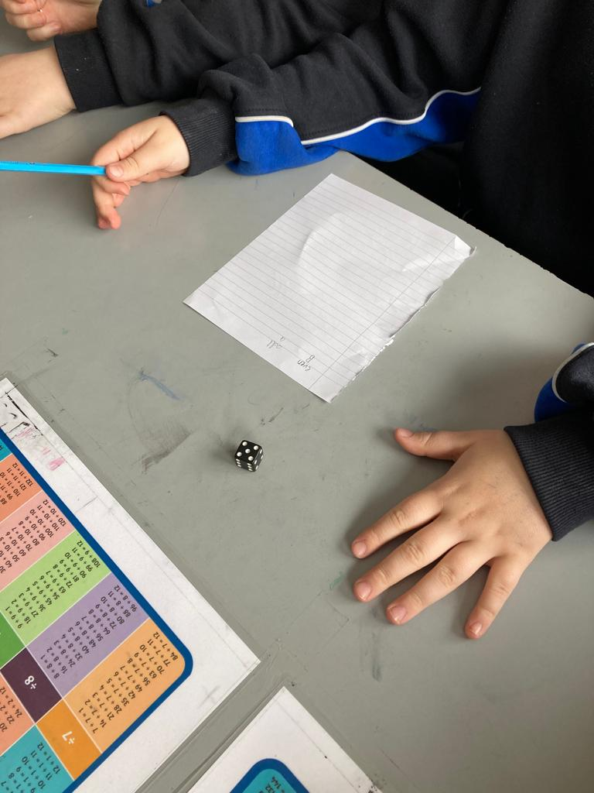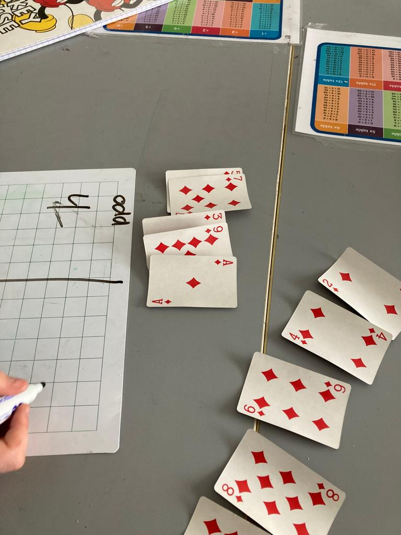MATHS EYES

MATHS EYES PROGRAMME.

Many children in the school have been developing their ‘maths eyes’

