Engineering in a Box
This year 5th class in Le Chéile NS engaged in the ‘Engineering in a Box’ science programme. The engineering in a box programme is based on the principles of STEM education. STEM (Science, Technology, Engineering, and Mathematics) education has numerous benefits for kids. Firstly, it encourages critical thinking and problem-solving skills, as children learn to hypothesize, experiment, and draw conclusions based on evidence. Secondly, STEM education helps to prepare children for future careers, as technology continues to play an increasingly important role in our society. Additionally, STEM education promotes creativity and innovation, as children learn to think outside the box and come up with new solutions to problems. The engineering in a box programme encourages children to think ouside the box through engaging them with hands on experiments and experiences. Finally, STEM education helps to develop scientific literacy, which is essential for success in all areas of life. Overall, STEM education offers numerous benefits that can have a lasting impact on children's academic and personal development.

Engaging the 5th class children in weekly science lessons in school has had numerous benefits for their academic and personal development. Here are some of the key advantages that I have noticed over the past few weeks.
The Engineering in a box programme has encouraged critical thinking and problem-solving skills amongst the children: Science lessons involve activities that promote critical thinking, logical reasoning, and problem-solving skills. Children learn to ask questions, hypothesize, experiment, and draw conclusions based on evidence. These skills are crucial for success in all areas of life. The children were encouraged to think critically and problem solve through the ‘Let’s build a paper skyscraper activity’. The children had to use only sheets of paper and glue in order to make a tall sky scraper that can support its own weight. Through trial and error the children were finally able to design a skyscraper that stood up straight.
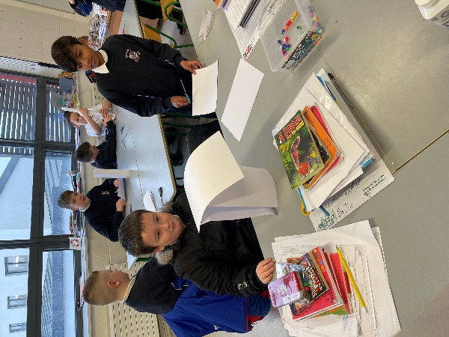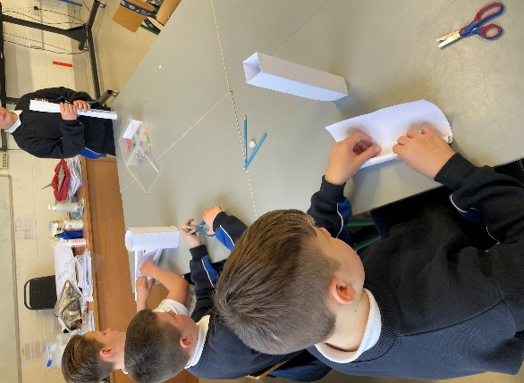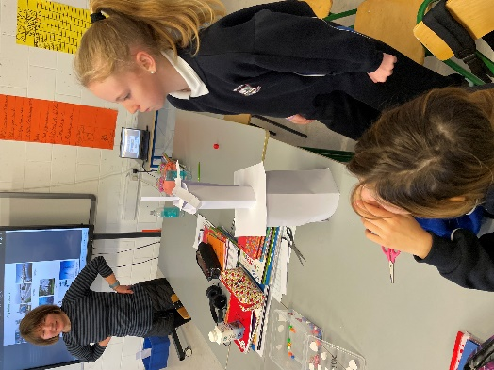
Engineering in a box has Increased the children’s curiosity and interest in the world: Science is all about exploring the world around us. By engaging in science lessons, children develop a natural curiosity and interest in the world. They learn to observe, explore, and investigate, which can spark a lifelong interest in science and technology. A lesson which captivated and stimulated the children’s interest in the world was the ‘Build a Bridge’ exercise. After studying various real life bridges such as the ‘Shannon Bridge’ in Limerick city centre the children were given the task of designing and building a bridge using lollypop sticks, foldback clips and rubber bands. The children learned about the principle of triangulation which enabled them to build a strong light bridge with a minimum amount of material.
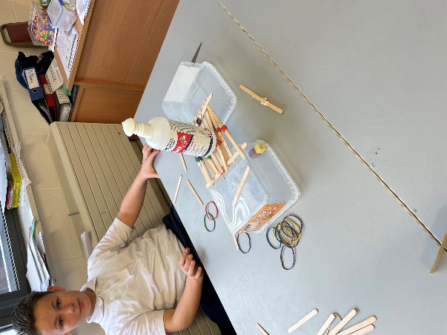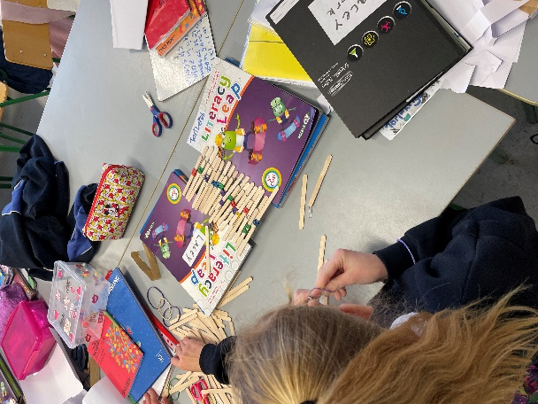
The engineering in a box programme has helped in developing the children’s concept of scientific literacy: Science literacy is the ability to understand scientific concepts and principles and apply them in real-life situations. Engaging in regular science lessons has helped the children develop a solid foundation in science, which has helped them in other subjects such as math, reading, and social studies. An example of a lesson which developed the children’s scientific literacy skills was the lesson on renewable and non renewable energy. This lesson taught the children how we ‘harness’ the wind in order to ‘generate’ renewable energy. After learning about renewable and non reneable energy the children were tasked with designing and creating a rotating windmill using cups, pipe covers, cocktail sticks and Sellotape.
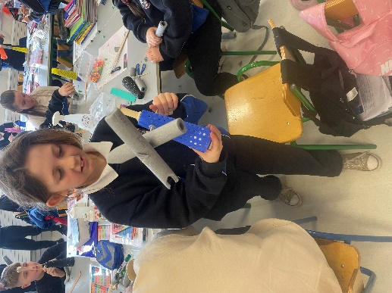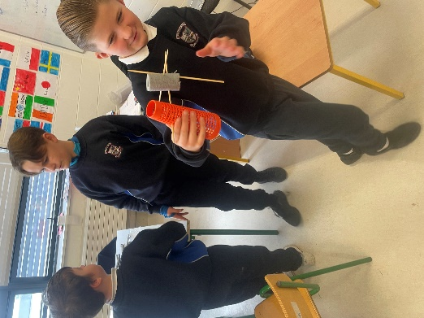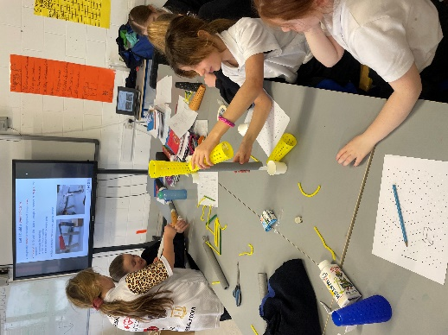
The engineering in a box programme has encouraged creativity and innovation among our 5th class students: Science lessons often involve hands-on activities that allow children to explore their creative side. They learn to think outside the box and come up with innovative solutions to problems. This can help them develop important skills that can be applied in other areas of life.
Another key advantage of the Engineering in a Box programme is is has Improved the childrens communication skills: Science lessons involve collaboration and communication. The children have learned to share their ideas and communicate their findings in a clear and concise manner. These skills are important for success in all areas of life, including school, work, and personal relationships.
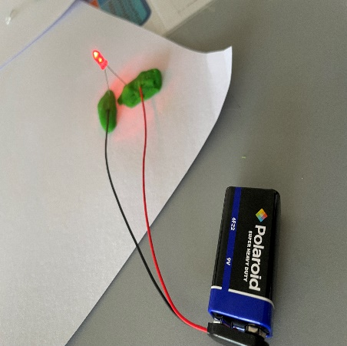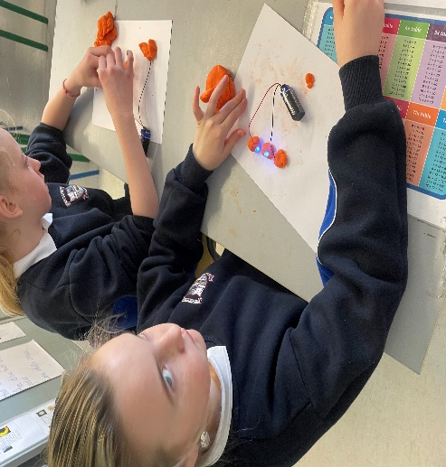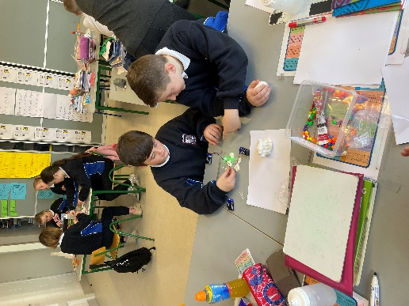
In conclusion engaging children in weekly science lessons in school has had numerous benefits for their academic and personal development. It has helped them develop critical thinking, problem-solving, scientific literacy, creativity, innovation, and communication skills, all of which are essential for success in the 21st century.

