Energy and Forces.
September 2022.
The story of Little Lumpty by Imai Miko was a big hit with Senior Infants this week.
They were excited to try help him down from the wall safely and without being scrambled like his cousin Humpty Dumpty.
They tried their best with a blanket, a nappy changing mat and a tea towel. It was great fun! Lumpty survived the fall with the blanket and nappy changing mat and everyone cheered. However,his luck ran out with the tea towel. Lumpty was scrambled. Some children thought it was because the tea towel was smaller and thinner. Others felt it was the force with which he fell!!
The children were disappointed by the demise of poor Lumpty but they loved the activity and engaged in a lively discussion, asking questions, making observations and giving explanations afterwards. 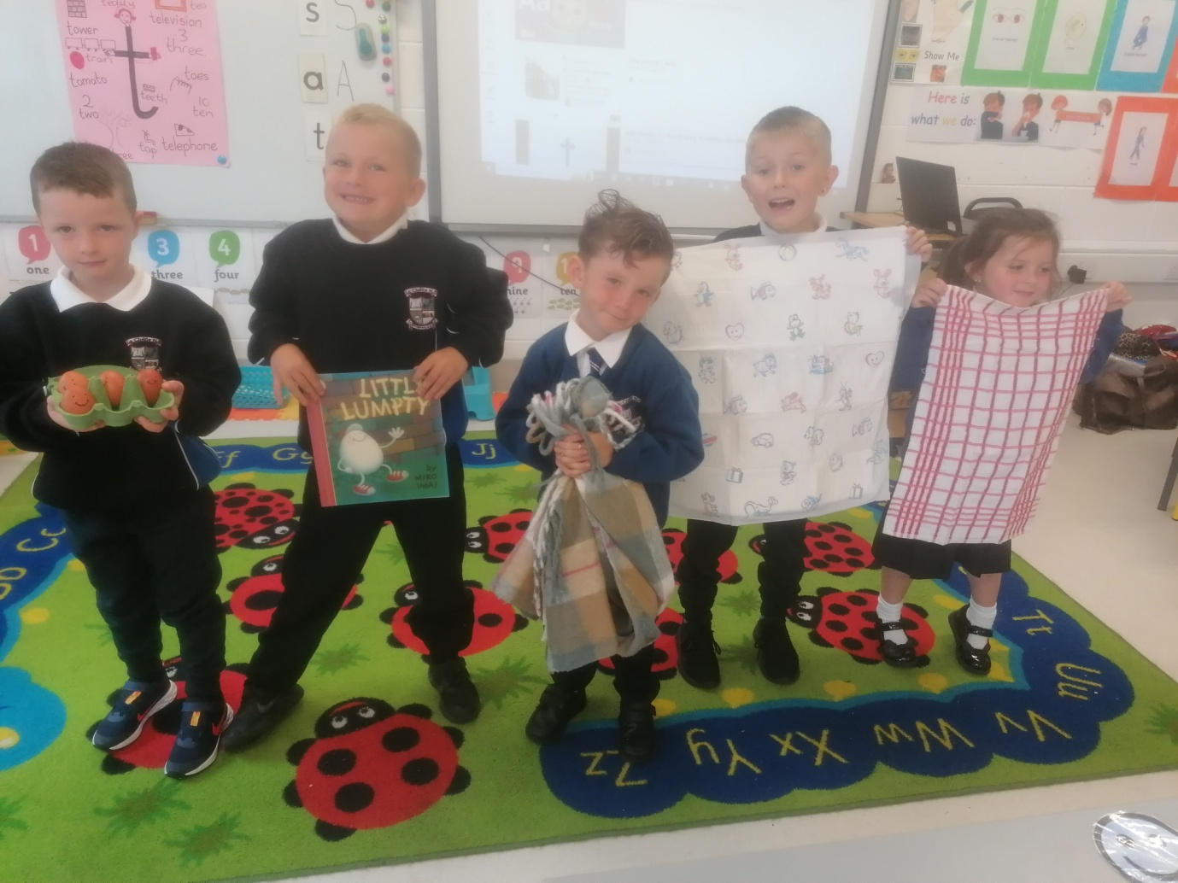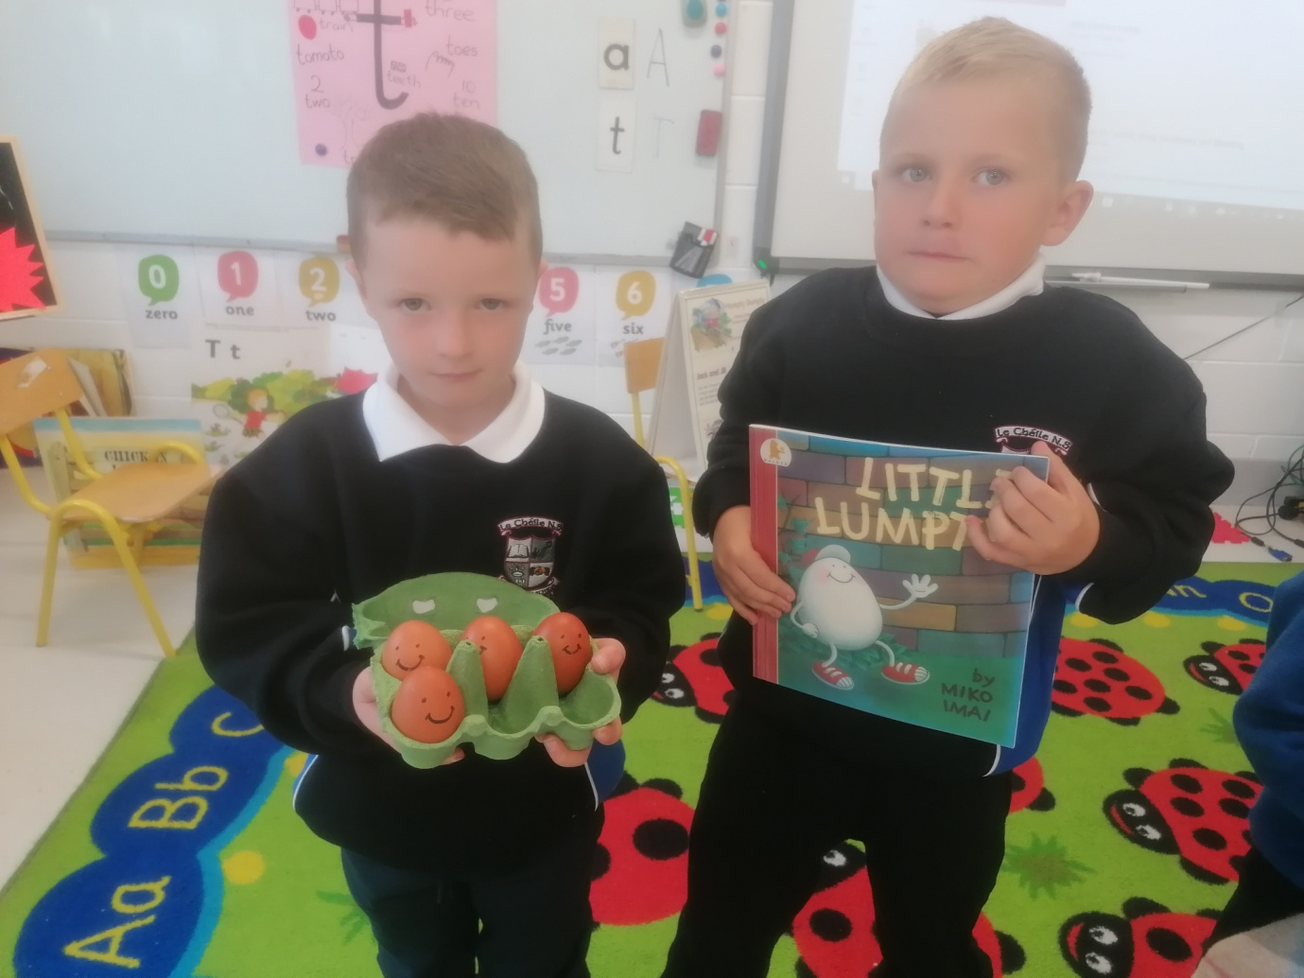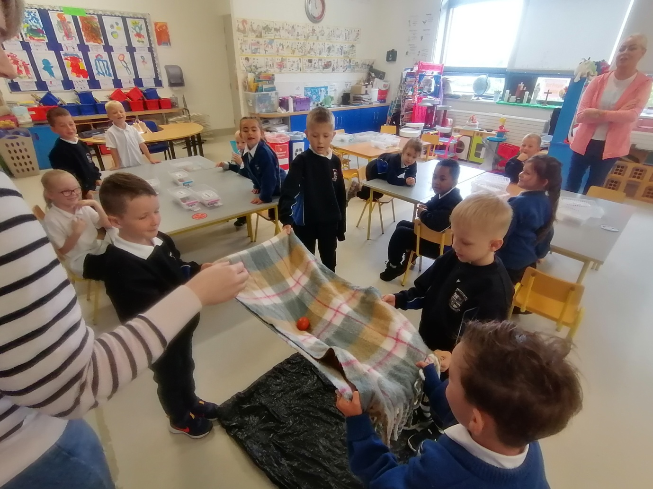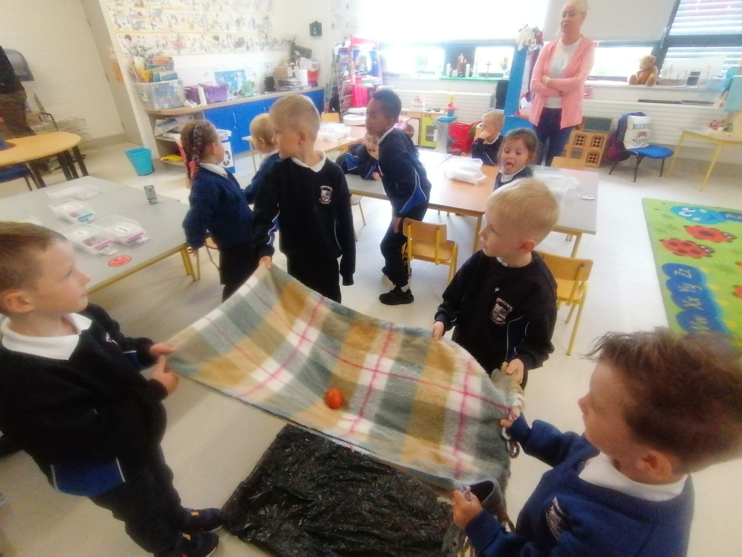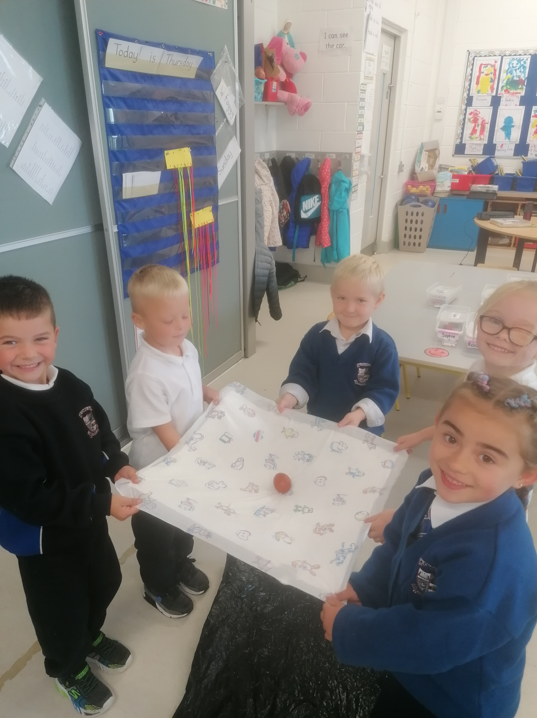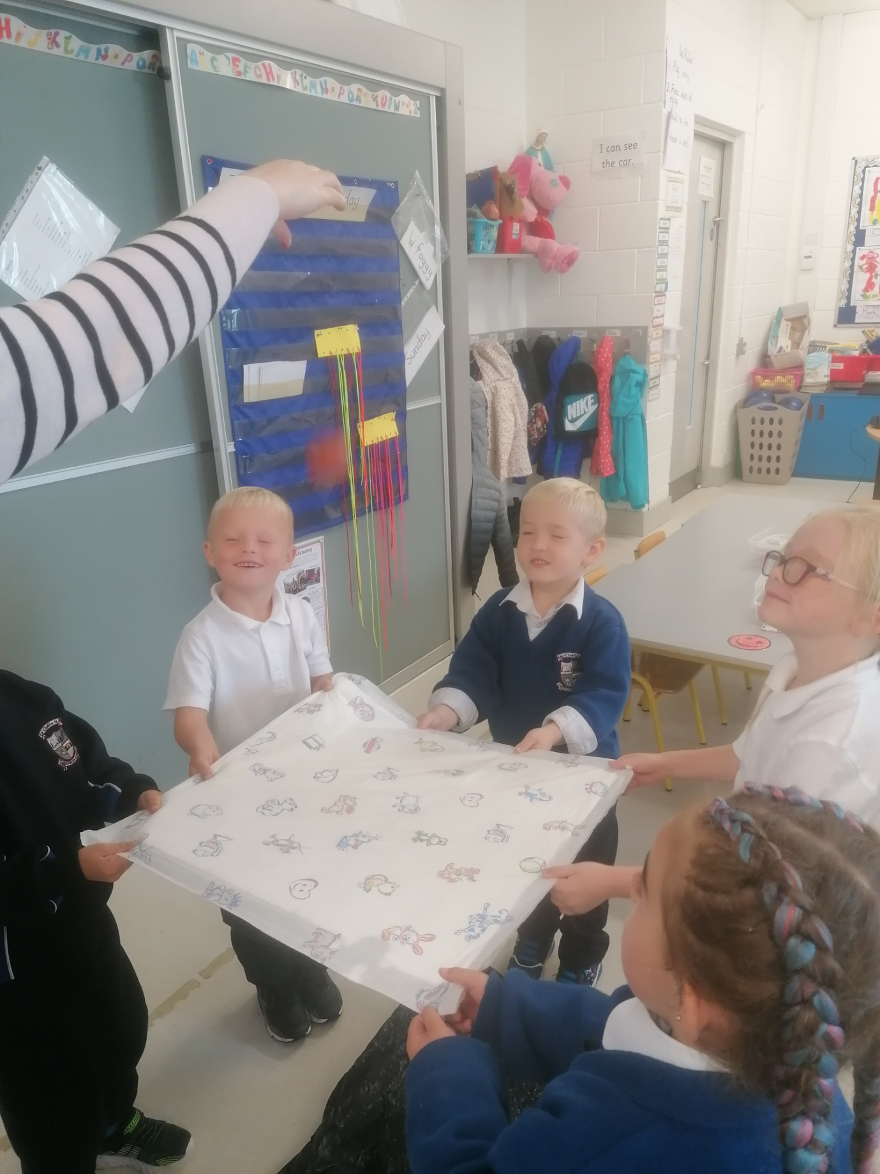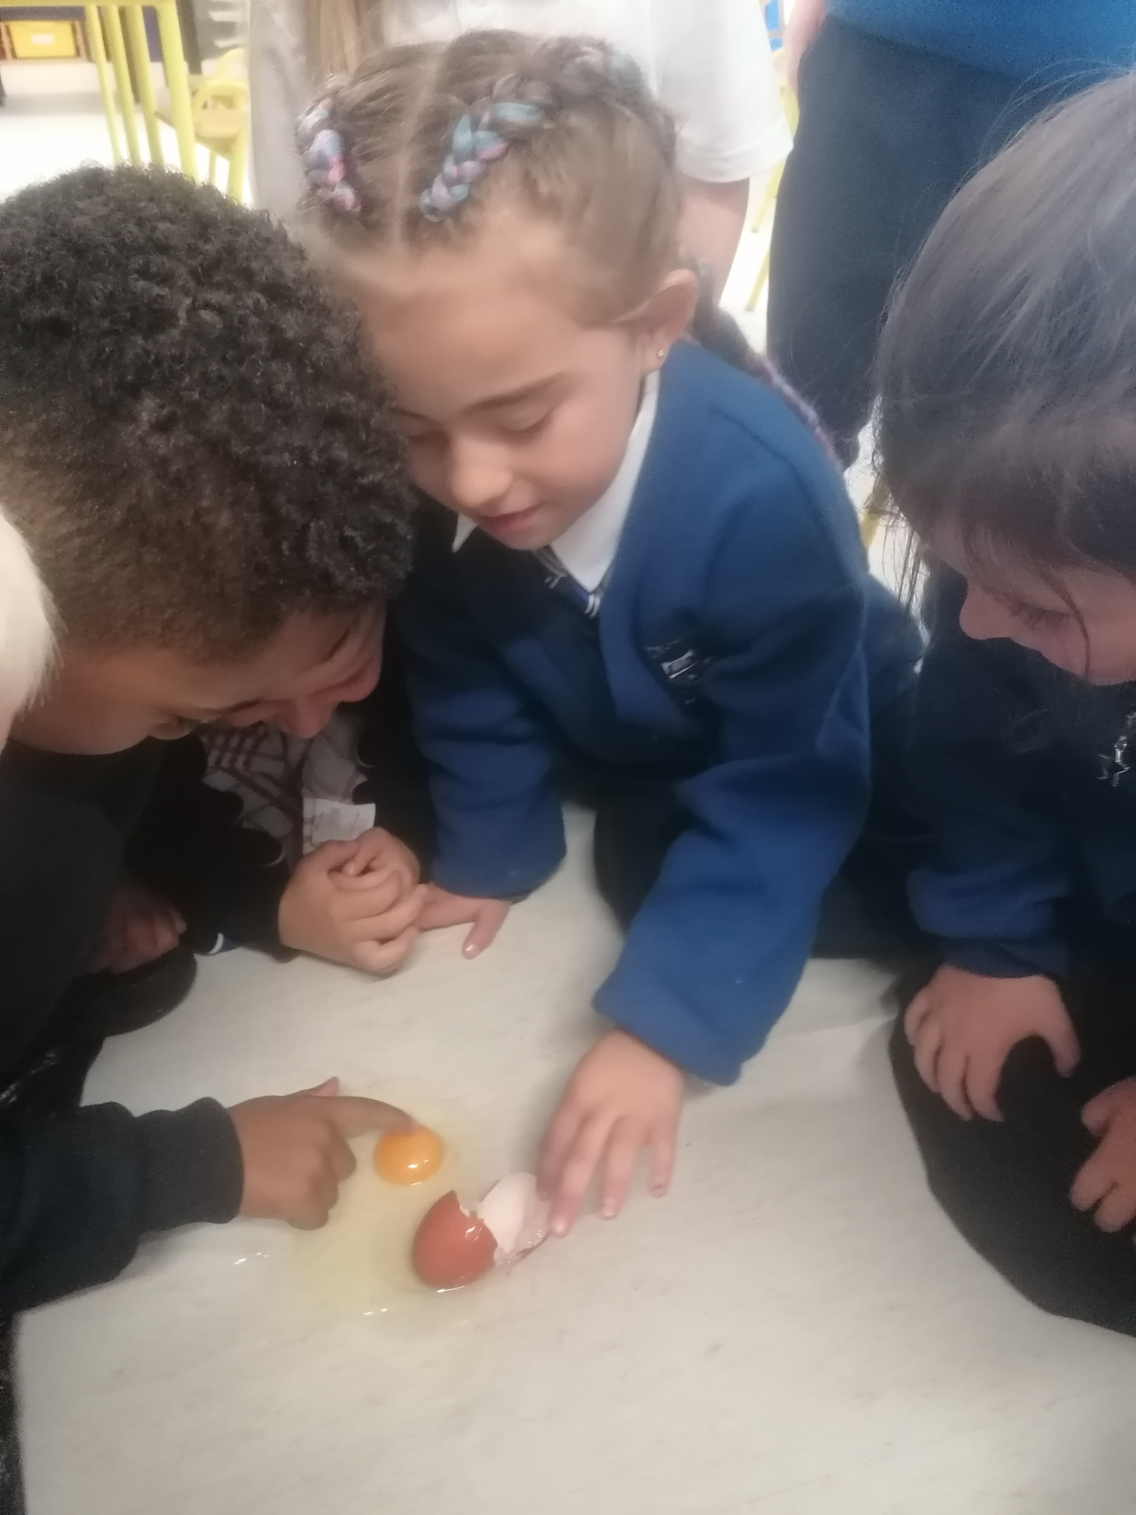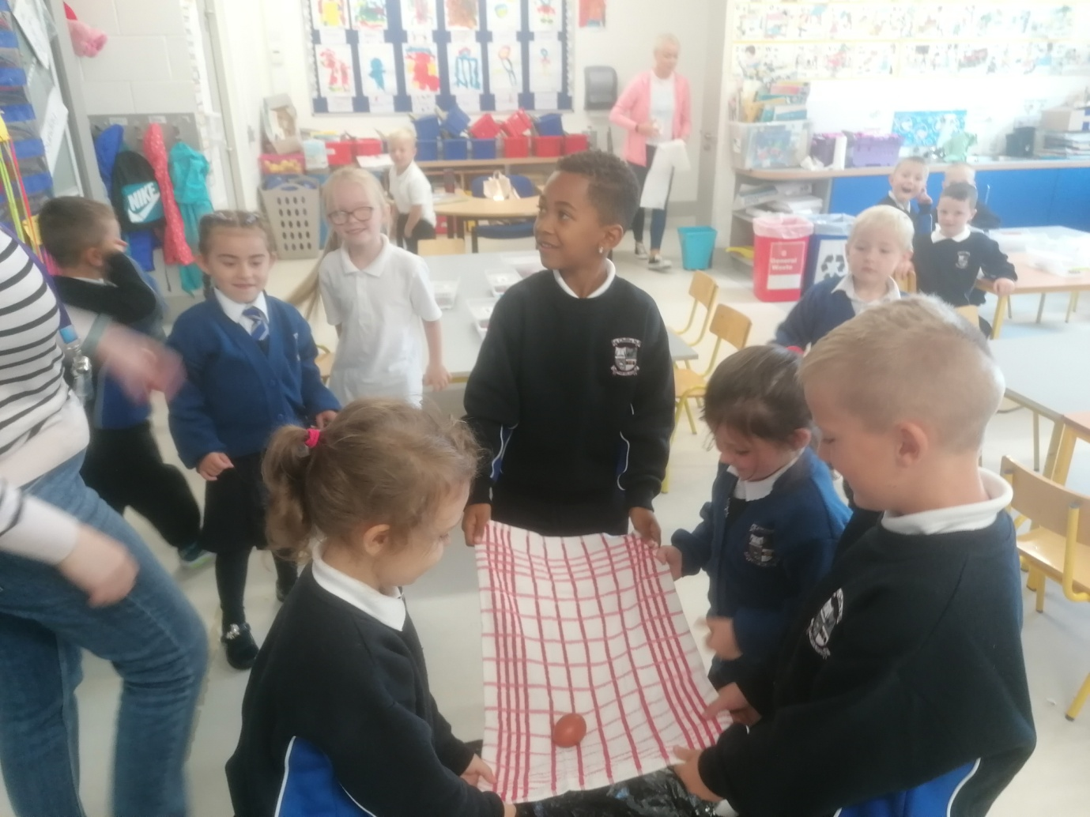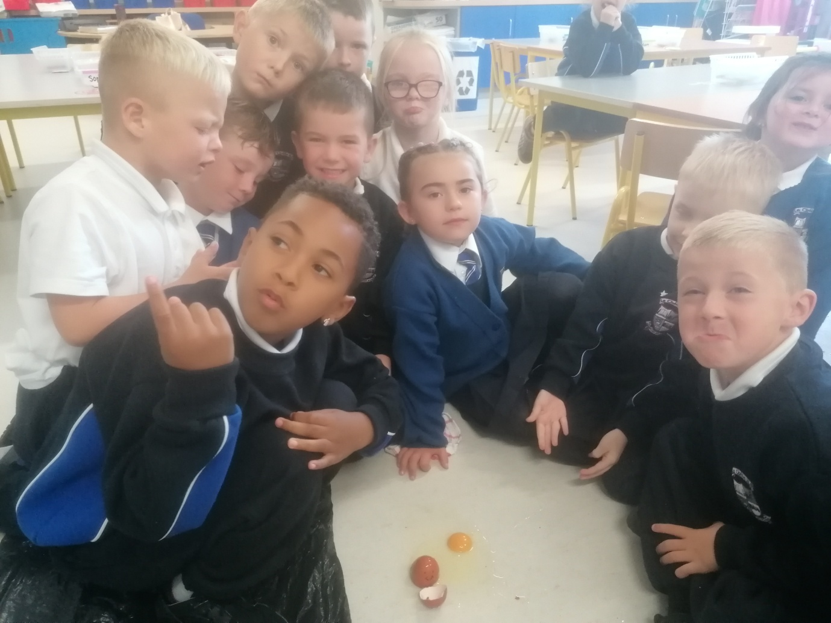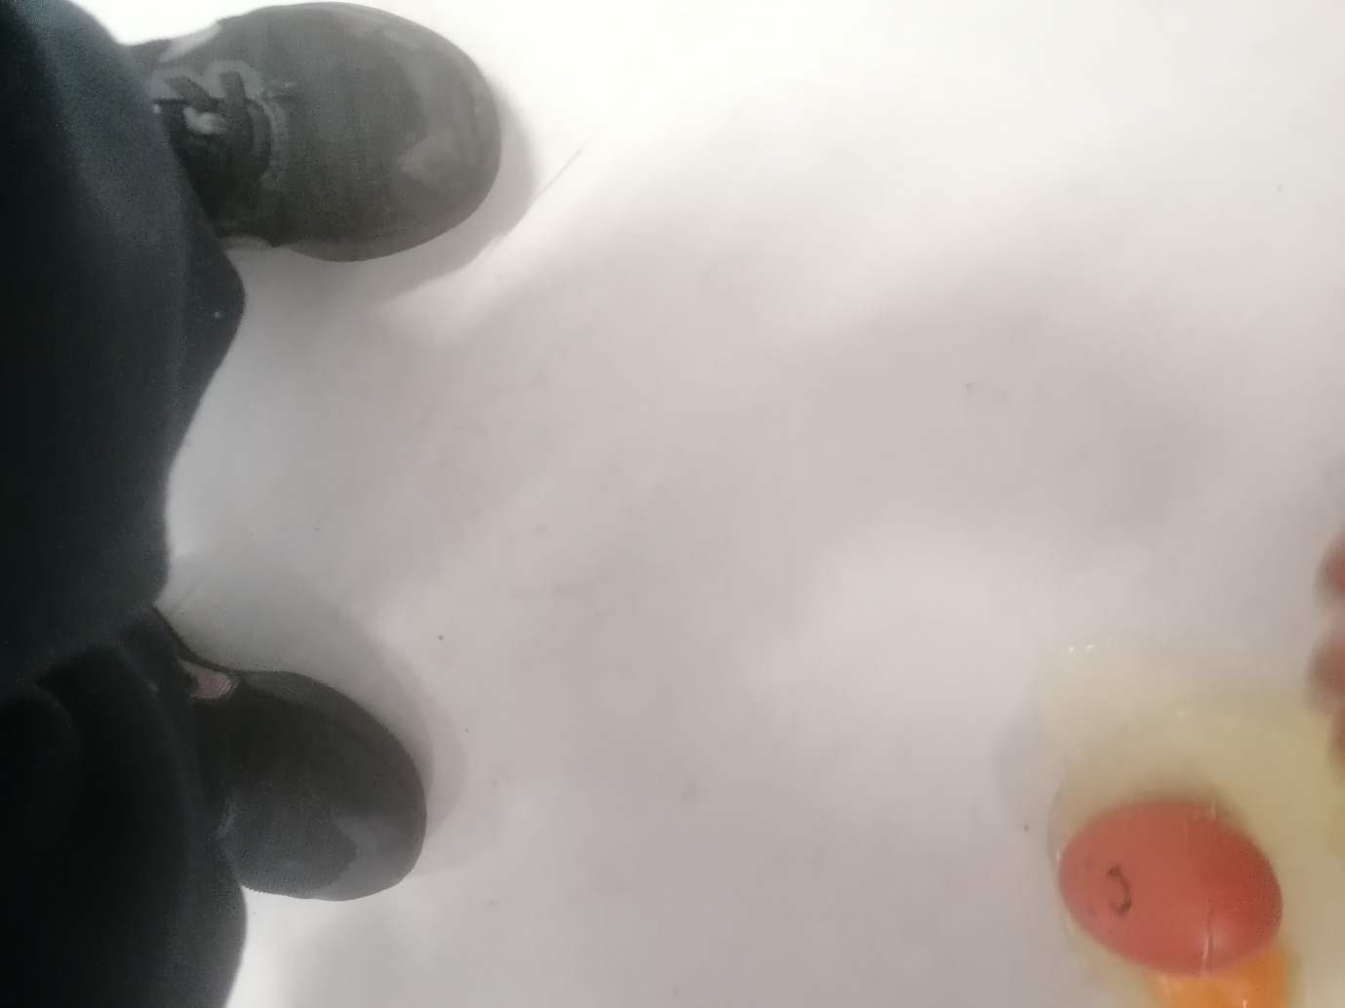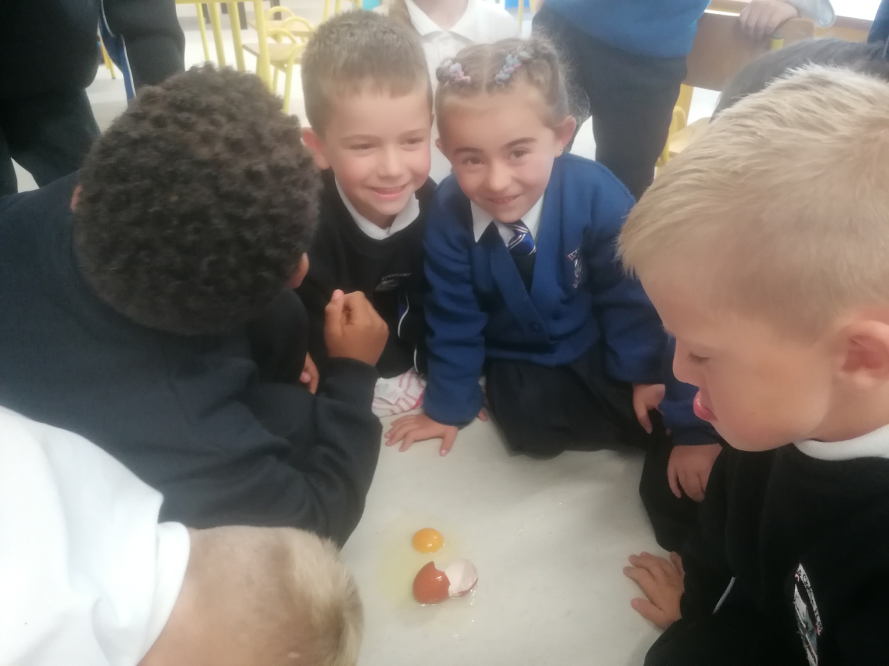 Energy and Forces.
Exploding Pumpkins October 2022.
Junior Infants had lots of Halloween fun with their pumpkins today.
They discovered that mixing baking soda and vinegar inside their pumpkin created carbon dioxide that made their pumpkin fizz, bubble and ‘explode’! 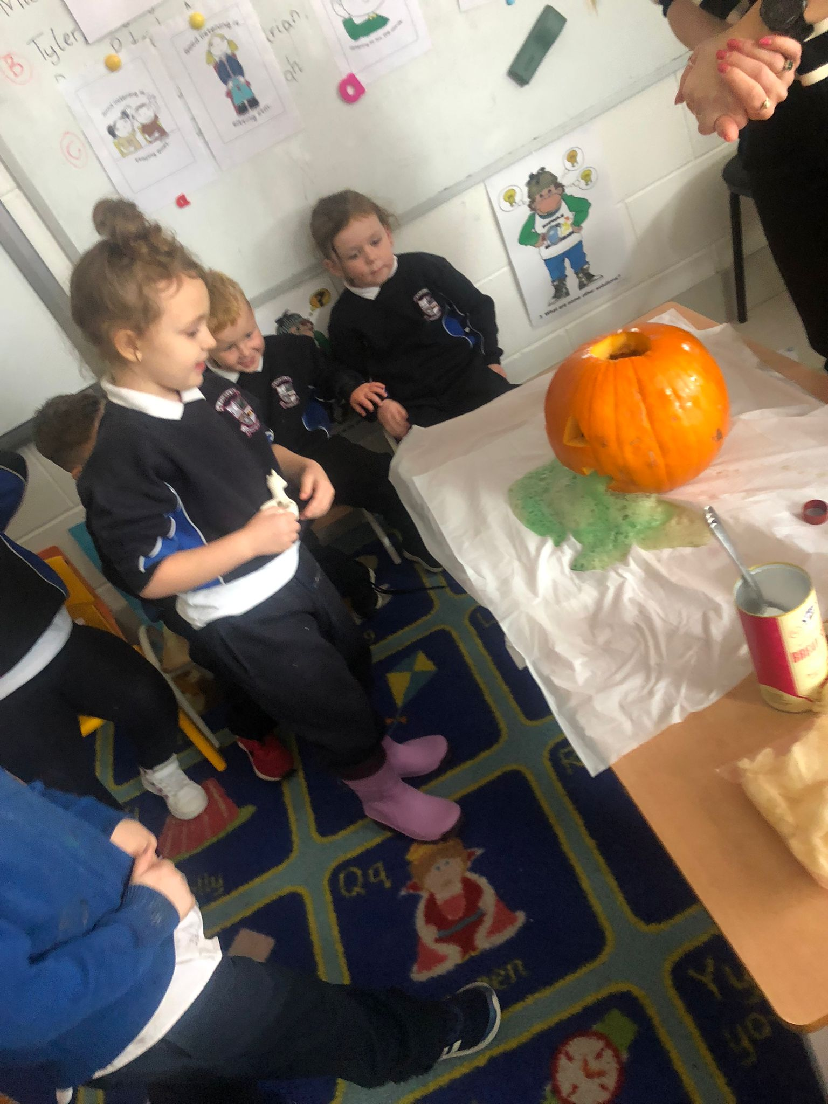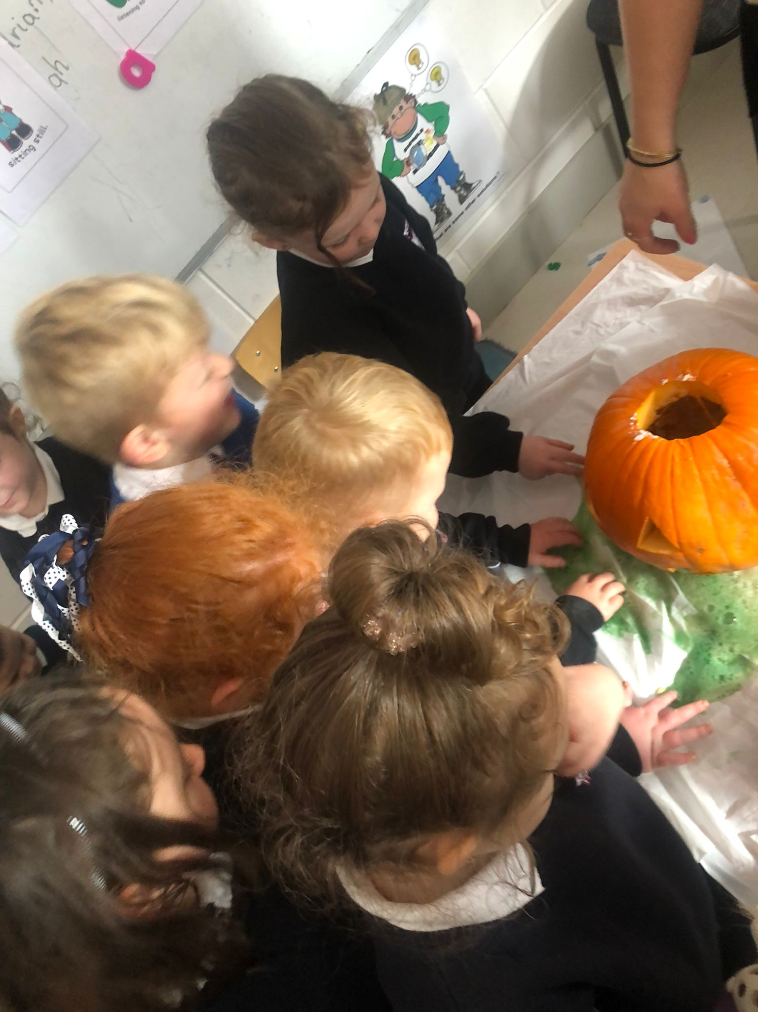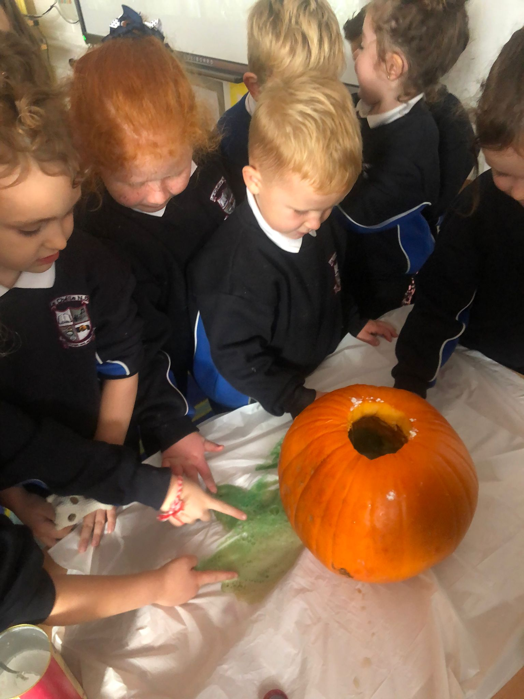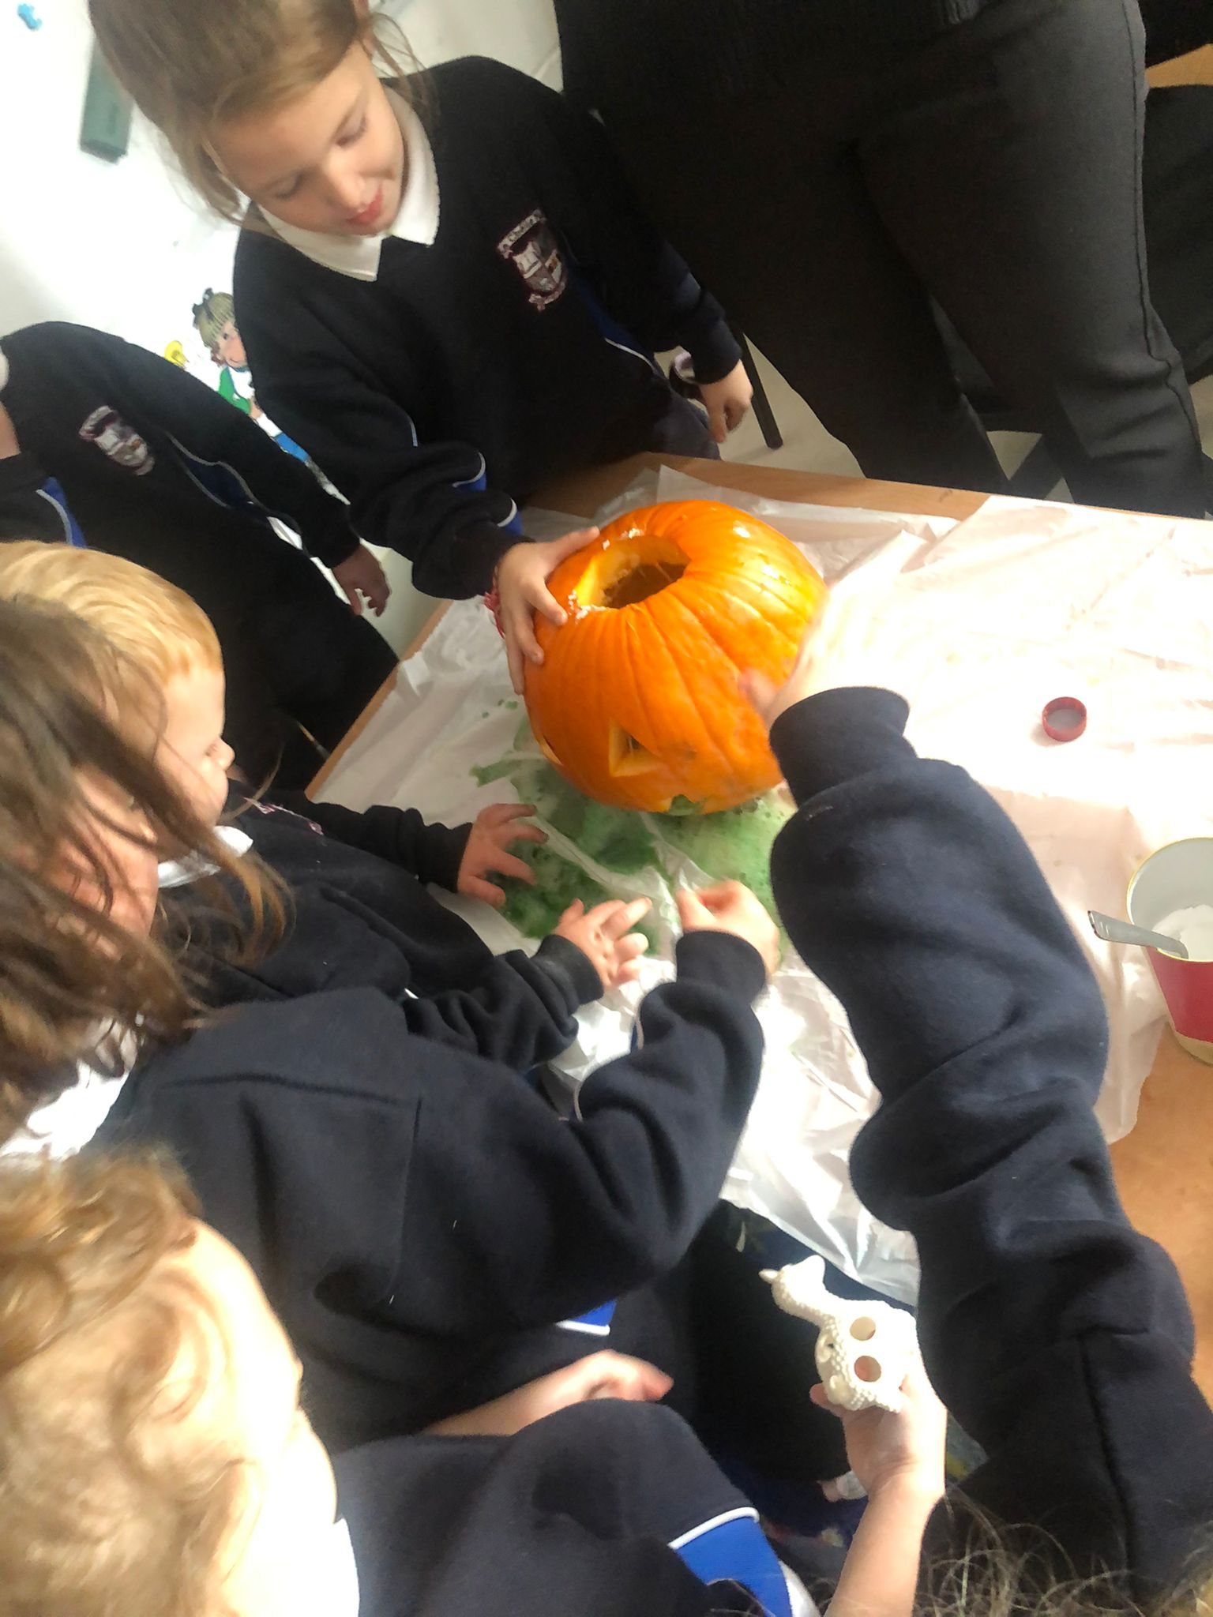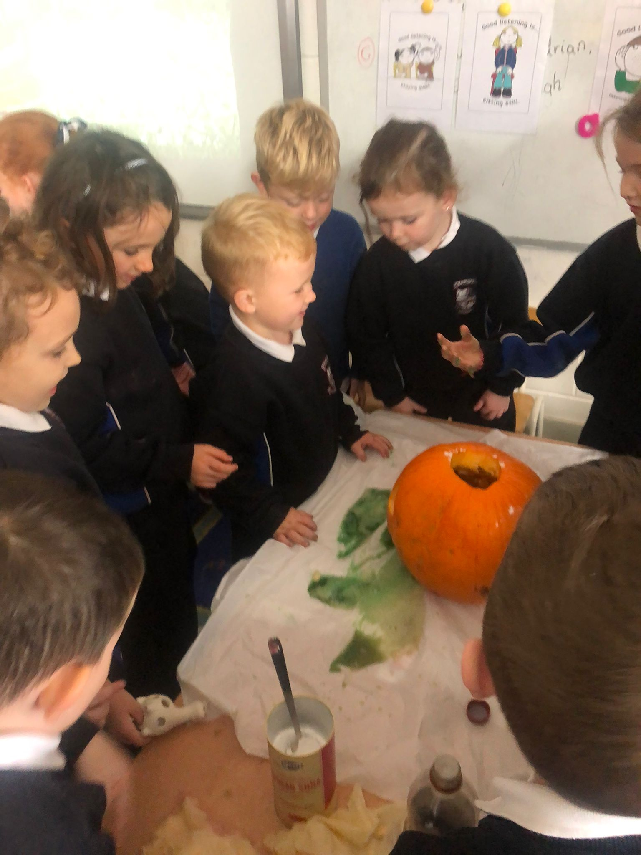

Energy and Forces.
Does it float or sink?
October 2022.

Senior Infants were busy this week predicting and investigating if objects in their classroom would float or sink. They recorded their findings.
They discovered a ball of playdough sinks. They designed and made boats with their play dough and tested them in the water.
One of our boats managed to hold 26 passengers (beans) before it sank.

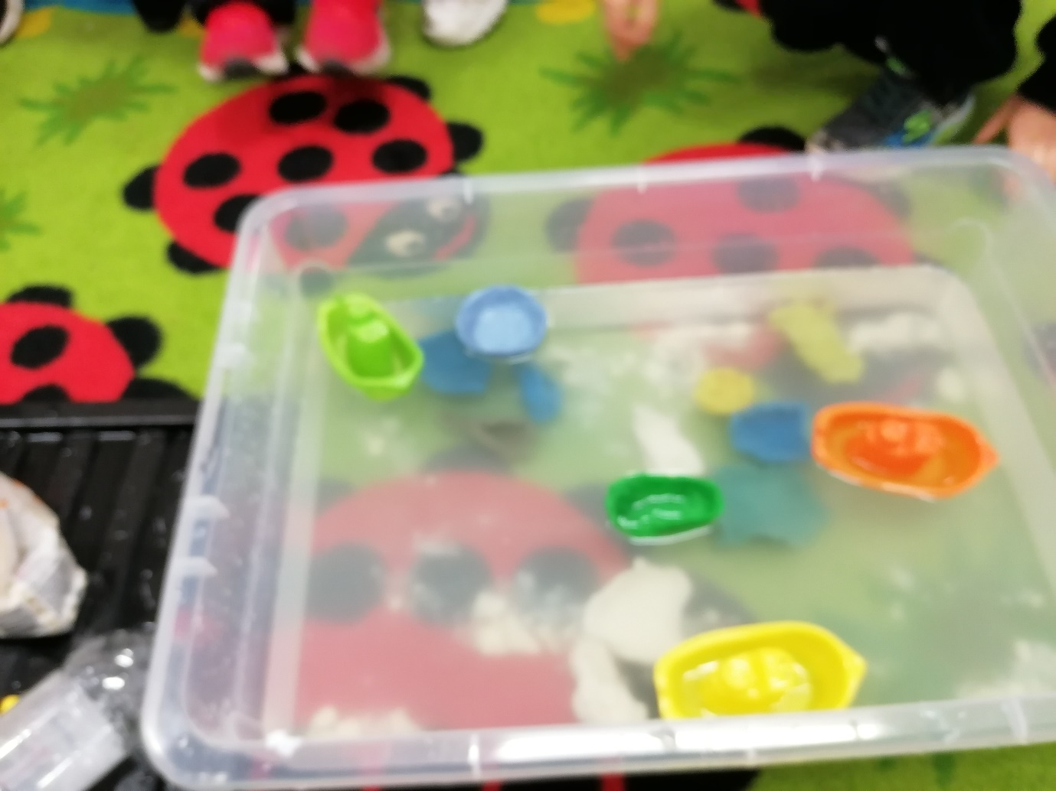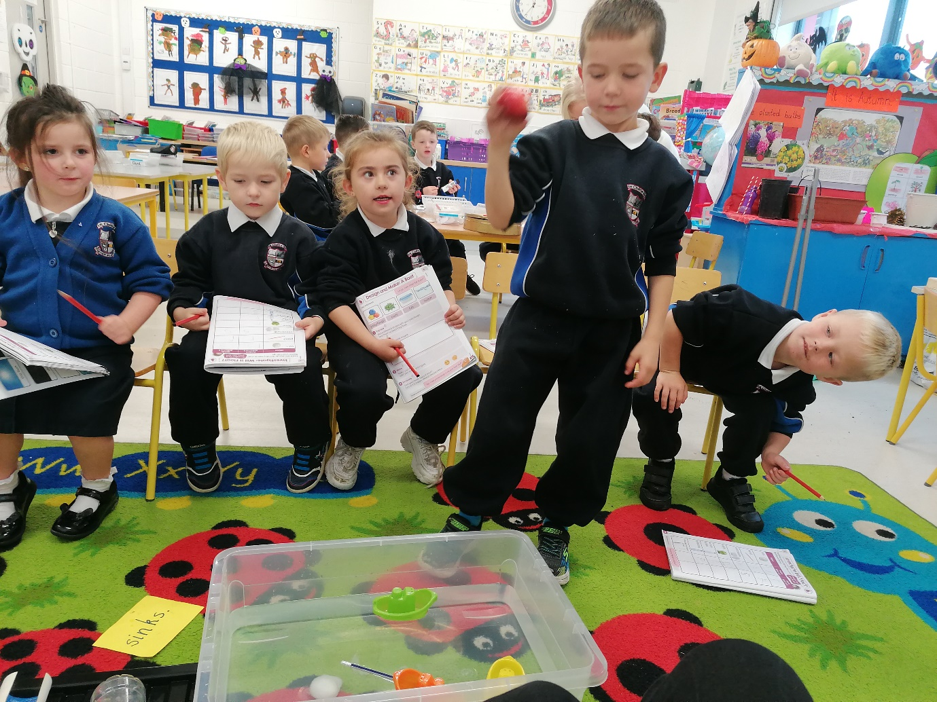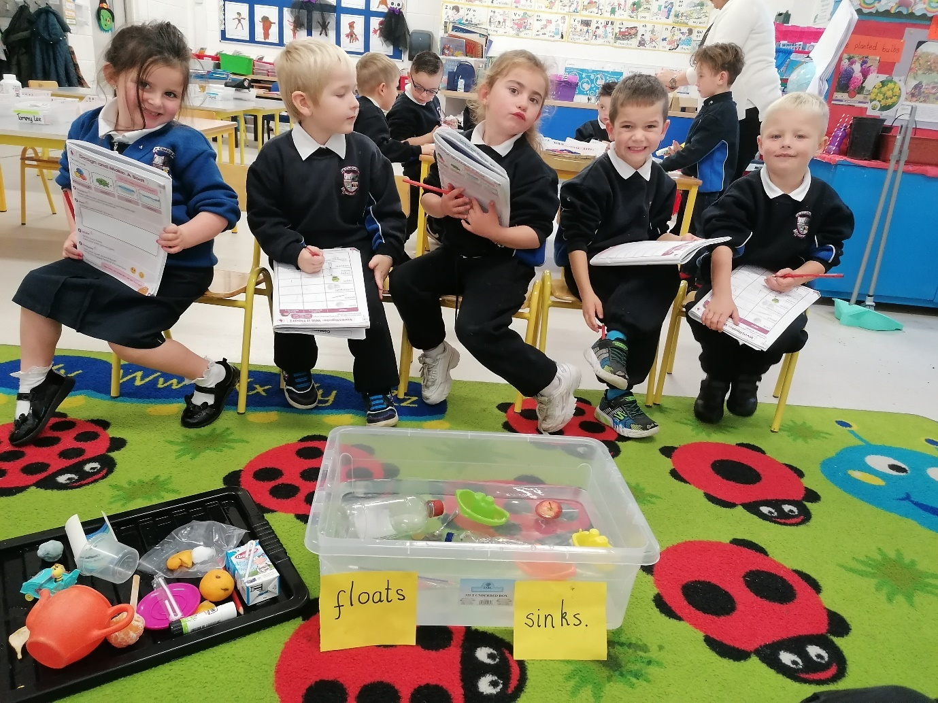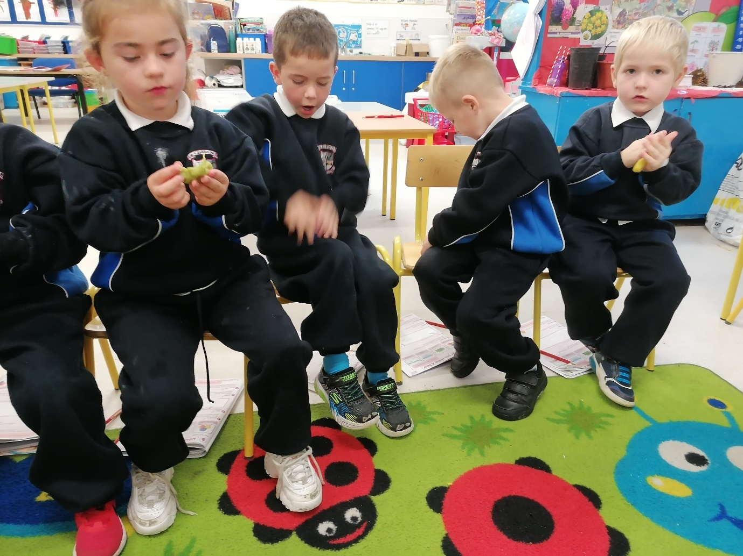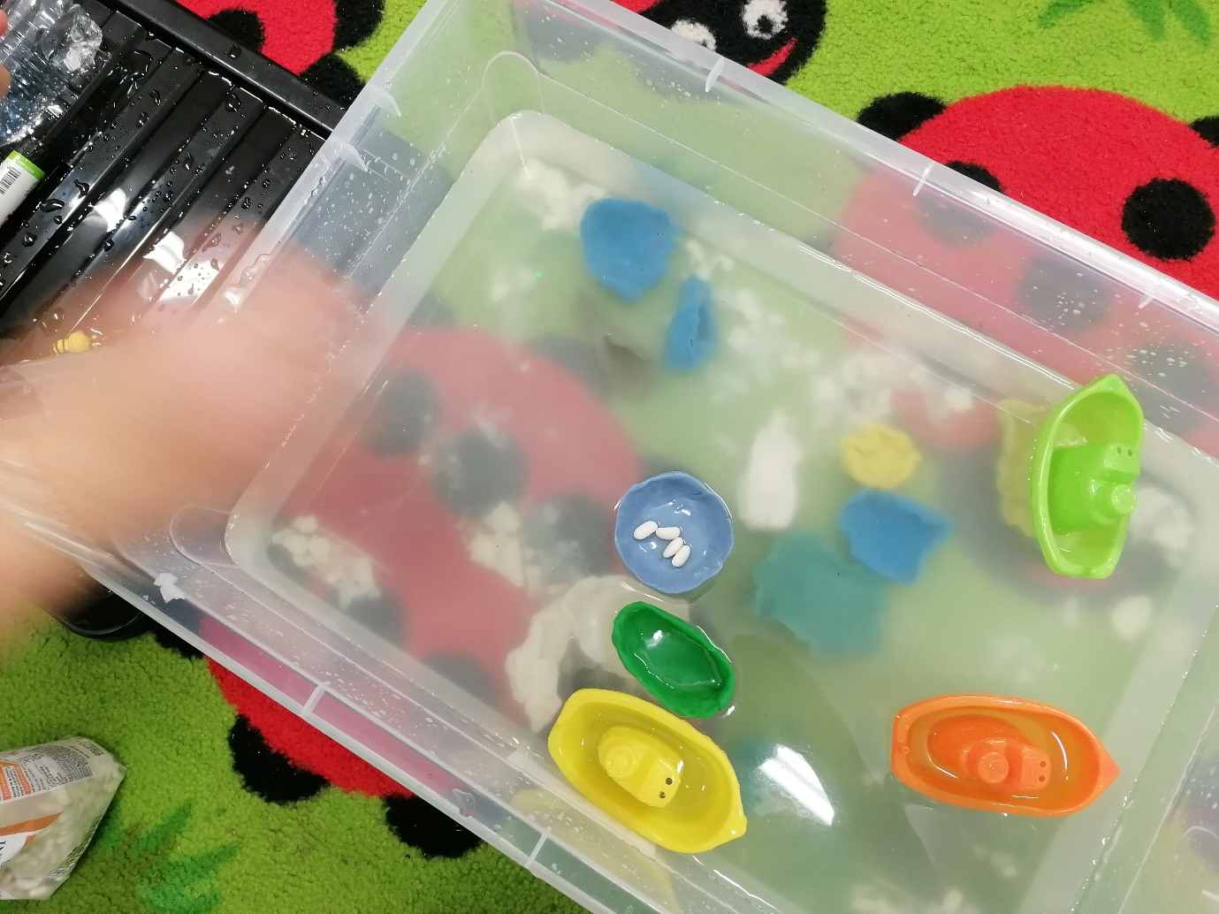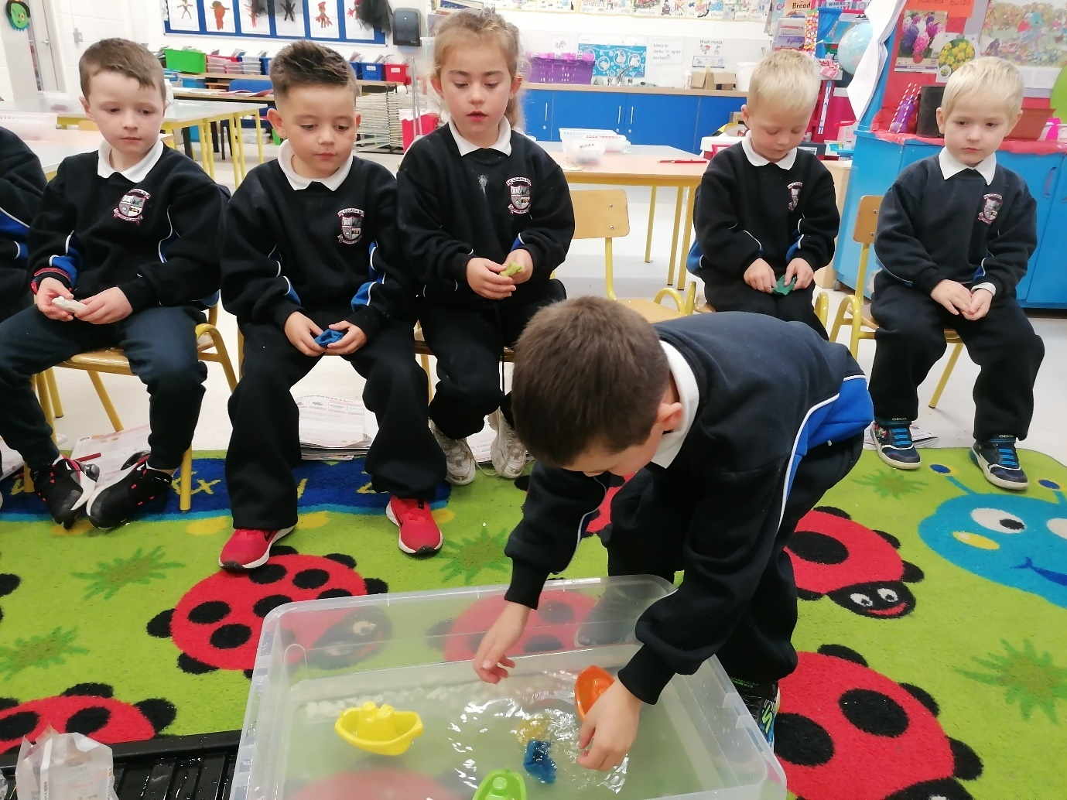 Energy and Forces.
Second Class - 18 November 2022.

Second Class had a workshop with Aoife from Lismore Heritage and Education centre today.
Her workshop taught us all about the different types of electricity. We really enjoyed working together to make our electrical circuits. We had to problem solve the best way to get our circuits to work. It was so much fun! 