4th and 6th classes

9th March 2023.

Hugo from the Learning Hub paid us a visit today. We had a very enjoyable and challenging workshop where we had to work together to build a boat.

BUILD-A-BOAT AND HOPE IT FLOATS ENGINEERING ACTIVITY

Dear Future Engineer,

Your challenge is to build a boat capable of floating as many coins as possible, you will be given the weight of one coin.

You will be provided a list of materials and their “prices” per unit, and a “worksheet”.

Build your boat to meet the size regulations (if any of the dimensions is exceeded, challenge is failed) within, and test how many coins it can float within allocated time – 45 minutes.

You will have to calculate the total cost of your boat.

This is a team challenge (you will be working in teams of 3 or 4), each team will need scissors, ruler, pencil, and a calculator.

Plan of action:
- First – split into teams.
- Second – draw your design of the boat (on the “worksheet”)
- Third – “purchase” your materials using the order form, plan the construction, calculate the total cost of materials
- Fourth – construct the boat.
- Fifth – when the boat is ready, let it be measured.
- Sixth – test your boat in a big bowl of water by carefully adding coins until it sinks, record the total number of coins, and calculate the total mass.

Knowing that 1 gram of the cargo (coins) is worth 10 cents, calculate the total value of the cargo (TVC):
TVC = Number of coins x Mass of one coin (grams) x 10 cents/gram
Calculate your score:
Score = Total cost / TVC
The winning team is the team with the smallest score (it might be a “BUILD-A-BOAT AND HOPE IT FLOATS”

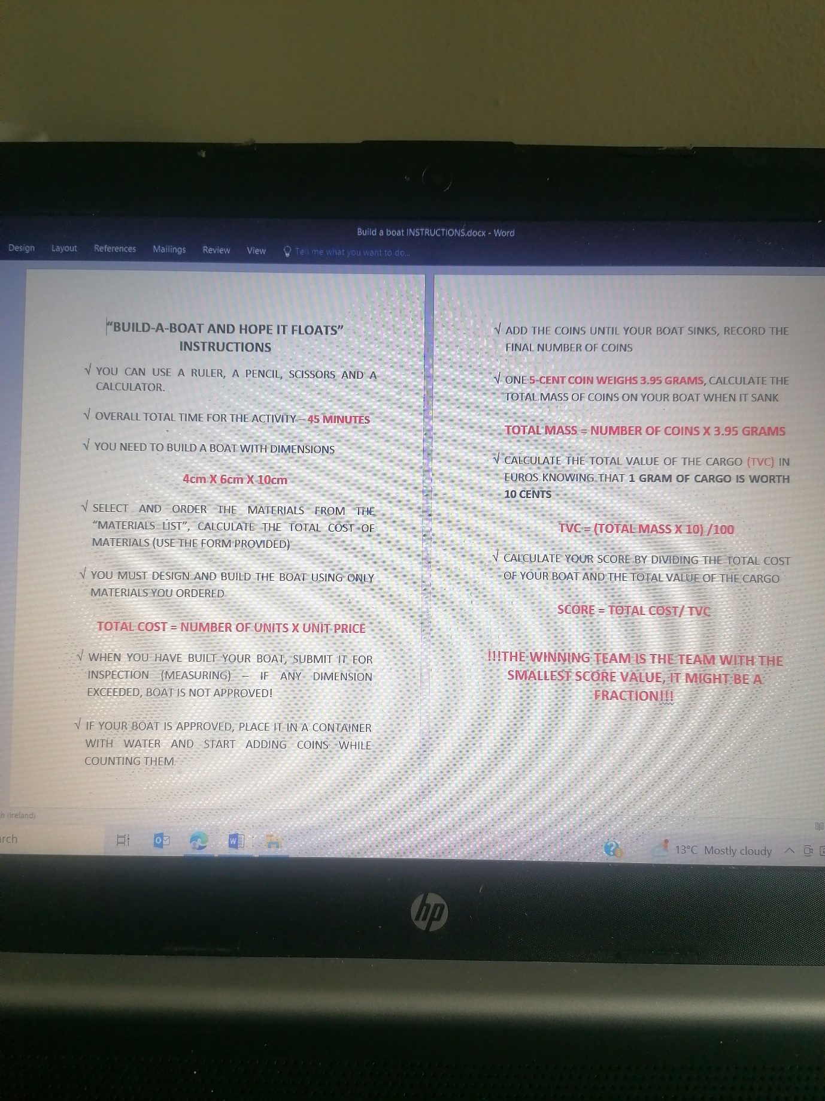

MATERIALS ORDER FORM

TEAM NAME:……………………………………………………………………..

MATERIAL | NUMBER OF UNITS | UNIT PRICE | COST

Total cost for the materials………………………..
